## Exploratory Data Analysis of US-English Twitter, Blogs, and News.
The Data were text files from the US. Text files from Twitter, Blogs, and News were analyzed separately, to identify the most commonly used words in each file.

# Load the required packages.
```{r}
library(tm)
library(ggplot2)

```

Load the text files from the Working Directory.
```{r}
tfilePath <- "C:/Users/mlrob/Documents/en_US/en_US.twitter.txt"
nfilePath <- "C:/Users/mlrob/Documents/en_US/en_US.news.txt"
bfilePath <- "C:/Users/mlrob/Documents/en_US/en_US.blogs.txt"
twitterlines <- readLines(tfilePath, skipNul = TRUE)
newslines <- readLines(nfilePath, skipNul = TRUE)
bloglines <- readLines(bfilePath, skipNul = TRUE)
#Analyze a random sample of .01 percent of the Twitter file.
twittersample <- twitterlines[rbinom(length(twitterlines)*.01,length(twitterlines),.01)]
newssample <- newslines[rbinom(length(newslines)*.1,length(newslines),.1)]
blogsample <- bloglines[rbinom(length(bloglines)*.03,length(bloglines),.03)]
#Load the data as a corpus
tdocs <- Corpus(VectorSource(twittersample))
ndocs <- Corpus(VectorSource(newssample))
bdocs <- Corpus(VectorSource(blogsample))
#Text transformation Twitter
#use the tm_map() function to replace special characters with a blank space.
#Special characters include /, #, &, â, \,®
toSpace <- content_transformer(function(x, pattern) gsub(pattern, " ", x))
tdocs <- tm_map(tdocs, toSpace, "â")
tdocs <- tm_map(tdocs, toSpace, "/")
tdocs <- tm_map(tdocs, toSpace, "@")
tdocs <- tm_map(tdocs, toSpace, "<")
tdocs <- tm_map(tdocs, toSpace, "~")
tdocs <- tm_map(tdocs, toSpace, "#")
tdocs <- tm_map(tdocs, toSpace, "Ÿ")
tdocs <- tm_map(tdocs, toSpace, "ð")
tdocs <- tm_map(tdocs, toSpace, "®")
tdocs <- tm_map(tdocs, toSpace, "\")
```
The tm_map function is used to remove unnecessary white space, to convert the text to lower case, to remove common stopwords like 'the','we'. The information values of stopwords is near 0 due to the fact that they are so common in a language. Removing this kind of words is useful before further analyses.
For 'stopwords', supported languages are danish, dutch, english, finnish, french, german, hungarian,italian, norwegian, portuguese, russian, spanish, and swedish.Language names are case sensitive.
```{r}
## Clean the text
#Convert to lower case
tdocs <-tm_map(tdocs, content_transformer(tolower))
#Remove numbers
tdocs <-tm_map(tdocs,removeNumbers)
#Remove common stopwords
tdocs <- tm_map(tdocs,removeWords, stopwords("english"))
# Remove punctuations
tdocs <- tm_map(tdocs, removePunctuation)
#Eliminate extra white spaces
tdocs <- tm_map(tdocs, stripWhitespace)
########################

#To get a list of the 25 most commonly used words in Twitter

dtm <- TermDocumentMatrix(tdocs)
m <- as.matrix(dtm)
v <- sort(rowSums(m),decreasing=TRUE)
d <- data.frame(word=names(v), freq=v)
head(d, 25)
d25<- d[1:25,]
print(d25)
```

#News and Blogs are analyzed separately in similar way.
#Text transformation News
#use the tm_map() function to replace special characters with a blank space.
# News had fewer special characters than twitter.
```{r}
toSpace <- content_transformer(function(x, pattern) gsub(pattern, " ", x))
ndocs <- tm_map(ndocs, toSpace, "$") #ok
ndocs <- tm_map(ndocs, toSpace, "-")
ndocs <- tm_map(ndocs, toSpace, "â")
ndocs <- tm_map(ndocs, toSpace, "\")
ndocs <- tm_map(ndocs, toSpace, "€")
ndocs <- tm_map(ndocs, toSpace, "#")
ndocs <- tm_map(ndocs, toSpace, "Â")
ndocs <- tm_map(ndocs, toSpace, "%")
ndocs <- tm_map(ndocs, toSpace, "™")
## Clean the text
#Convert to lower case
ndocs <-tm_map(ndocs, content_transformer(tolower))
#Remove numbers
ndocs <-tm_map(ndocs,removeNumbers)
#Remove common stopwords
newsdocs <- tm_map(newsdocs,removeWords, stopwords("english"))
# Remove punctuations
ndocs <- tm_map(ndocs, removePunctuation)
#Eliminate extra white spaces
ndocs <- tm_map(ndocs, stripWhitespace)
```
Here's a list of the 25 most commonly used words in News
```{r}
newsdtm <- TermDocumentMatrix(ndocs)
newsm <- as.matrix(newsdtm)
v <- sort(rowSums(newsm),decreasing=TRUE)
newsd <- data.frame(word=names(v), freq=v)
head(newsd, 25)
newsd25<- d[1:25,]
print(newsd25)
```
#Analyze blogs
```{r}

#Text transformation
#use the tm_map() function to replace special characters with a blank space.

toSpace <- content_transformer(function(x, pattern) gsub(pattern, " ", x))
bdocs <- tm_map(bdocs, toSpace, "$")
bdocs <- tm_map(bdocs, toSpace, "â")
bdocs <- tm_map(bdocs, toSpace, "\")
bdocs <- tm_map(bdocs, toSpace, "œ")
bdocs <- tm_map(bdocs, toSpace, "€")
bdocs <- tm_map(bdocs, toSpace, "™")
## Clean the text
#Convert to lower case
bdocs <-tm_map(newsdocs, content_transformer(tolower))
#Remove numbers
bdocs <-tm_map(newsdocs,removeNumbers)
#Remove common stopwords
bdocs <- tm_map(newsdocs,removeWords, stopwords("english"))
# Remove punctuations
bdocs <- tm_map(newsdocs, removePunctuation)
#Eliminate extra white spaces
bdocs <- tm_map(bdocs, stripWhitespace)

#Here's a list of the 25 most commonly used words in Blogs

bdtm <- TermDocumentMatrix(bdocs)
bm <- as.matrix(bdtm)
v <- sort(rowSums(bm),decreasing=TRUE)
bd <- data.frame(word=names(v), freq=v)
head(bd, 25)
bd25<- bd[1:25,]
print(bd25)
```
#Frequency word plots are here as follows
```{r}
barplot(d25$freq, las=2, names.arg=d25$word, col="lightblue",main="most frequent words
in Twitter",
ylab="Word frequencies")

barplot(newsd25$freq, las=2, names.arg=d25$word, col="lightblue",main="most frequent words
in News",
ylab="Word frequencies")

barplot(bd25$freq, las=2, names.arg=d25$word, col="lightblue",main="most frequent words
in Blogs",
ylab="Word frequencies")
```

The 25 most commonly used words in Twitter

word freq
the the 10844
you you 5996
and and 4884
for for 4480
that that 2494
your your 1974
with with 1845
have have 1837
this this 1812
all all 1783
get get 1776
just just 1642
out out 1473
good good 1361
are are 1348
like like 1279
but but 1258
new new 1232
know know 1230
day day 1192
thanks thanks 1190
its its 1176
lol lol 1103
dont dont 1073
not not 1071
>

The 25 most commonly used words in blogs
word freq
the the 55174
and and 30672
that that 11805
for for 9747
with with 8351
this this 7533
was was 7177
you you 6983
but but 6431
have have 5683
not not 5297
are are 5053
from from 4464
they they 4322
all all 3959
will will 3931
one one 3630
has has 3439
about about 3264
just just 3170
can can 3096
when when 3002

The 25 most commonly used words in News

word freq
the the 55174
and and 30672
that that 11805
for for 9747
with with 8351
this this 7533
was was 7177
you you 6983
but but 6431
have have 5683
not not 5297
are are 5053
from from 4464
they they 4322
all all 3959
will will 3931
one one 3630
has has 3439
about about 3264
just just 3170
can can 3096
when when 3002
there there 2993
their their 2939
some some 2868
>

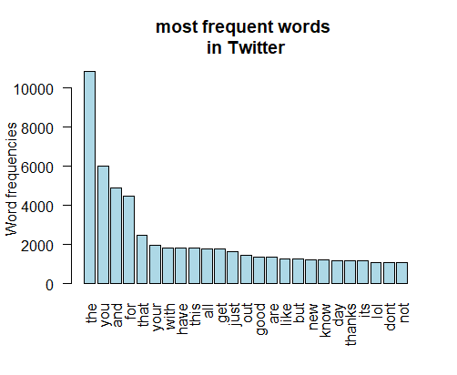

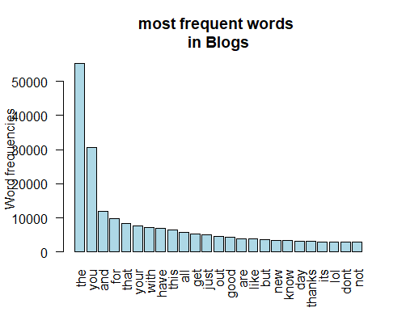

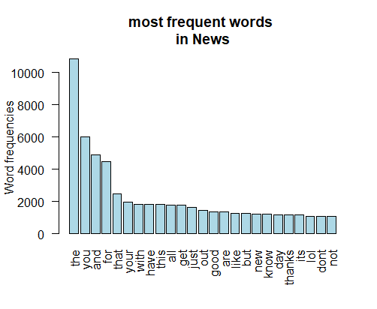

On examining the most frequently used words, twitter, blogs and news words are nearly the same, appearing in mostly the same order. The most commonly used words in all three sources were the, you, and, for, that.

Creating a prediction algorithm: As the three feeds use mostly the same words, the same
prediction algorithm can be used for all three sources.

The goal next is to be able, given a word is typed in, to predict the next word to be typed in. The first step would be to get a list of the most commonly used bigrams. The list could be split into first words and their corresponding second words. Next write a model to predict the second word give the first word.

Next tokenize the text into trigrams. Given the first two words that were typed in, predict the third word. Test several predictive models, and using predictive modeling principles, determine the most accurate model.

